Jonathan Nicolosi

CS340 Project

**Outline**:

The purpose of this website is to allow someone to create a fantasy NBA team by selecting players and coaches from a database. The database contains four tables: players, coaches, team, and accolades. Inside each table, there are some columns with statistics. The user can search for players by team, by college, or by accolade. The search results will then populate below. The user can then select which players he/she wants to be on his/her fantasy team, hit “Add Player(s) to Roster” and the selection(s) will be inserted into the fantasy table. The contents of the fantasy table are displayed below in the panel entitled “Fantasy Team”.

**Database Outline:**

Players have IDs, first names, last names, college attended, and team played for. They are uniquely identified by their ID.

Teams have IDs, season, record (per season), coach, city, and name. They are uniquely identified by their ID.

Coaches have IDs, names, years as coach, regular season record, playoff records, conference championships won, and championships won.

Accolades have IDs, season, first name (of player), last name (of player), and award won.

A player is from one university.

Each team has many players but each player plays for a single team.

Each player has many teammates. Each teammate has many teammates.

Players have many accolades and players can be awarded the same thing (albeit in different seasons, i.e. no two players can get MVP in a single season)

**ER Diagram:**

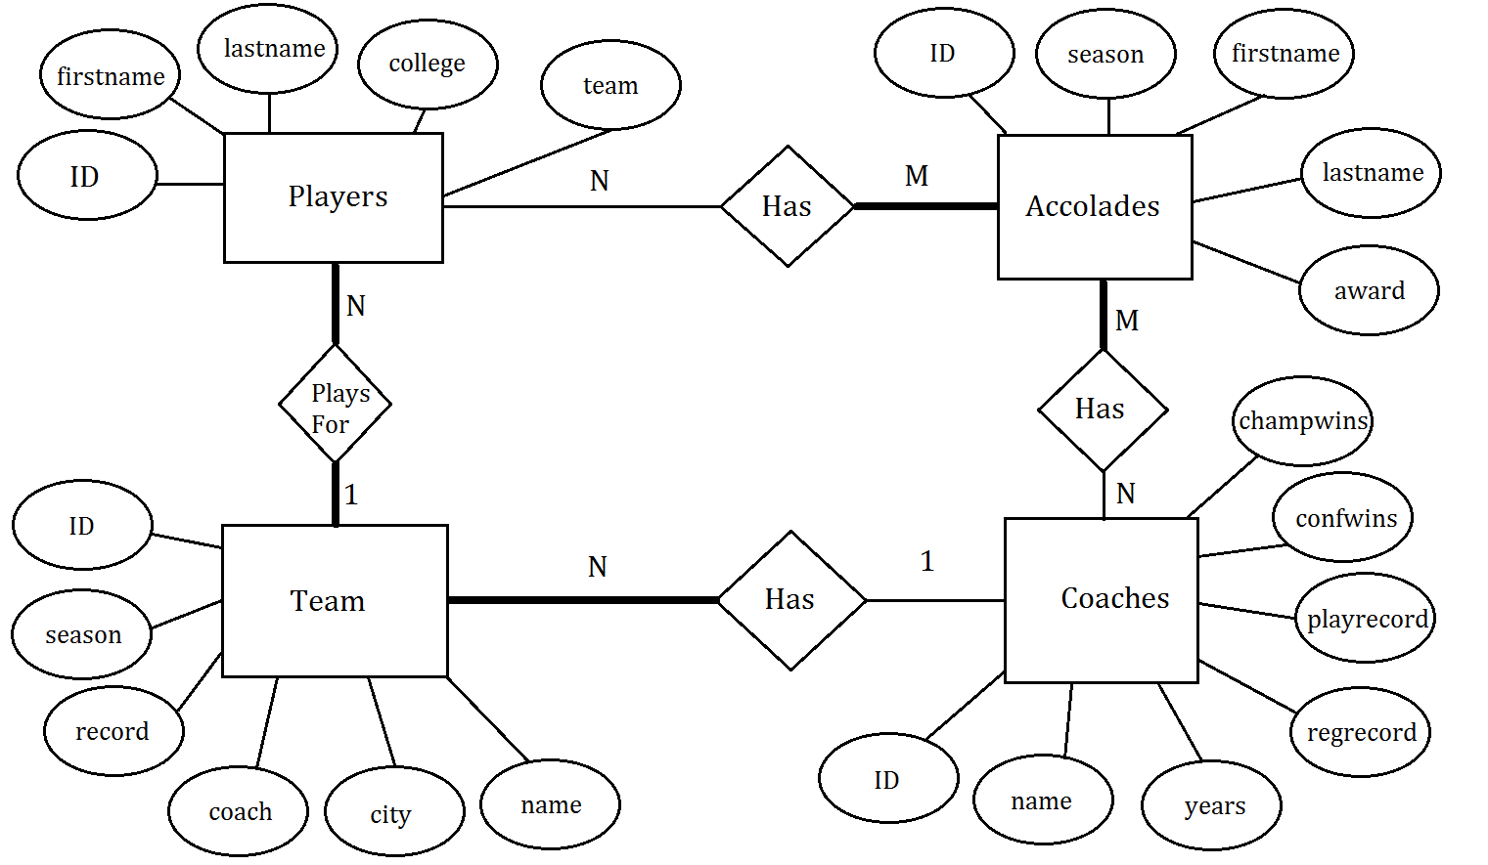

**Schema:**

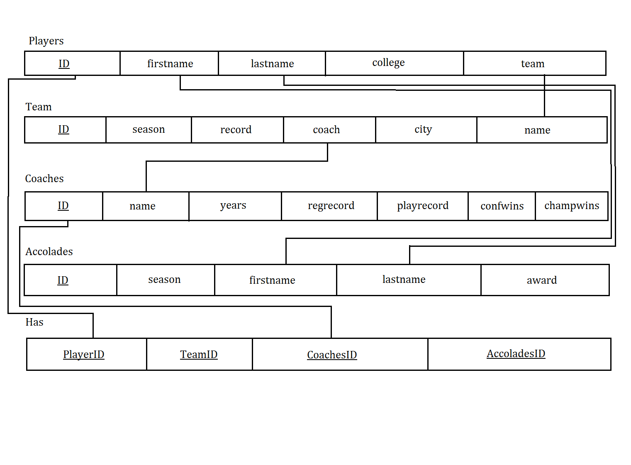

**Table Creation Queries:**

CREATE TABLE `nicolosj-db`.`players` (

`id` INT( 11 ) NOT NULL AUTO_INCREMENT PRIMARY KEY ,

`firstname` VARCHAR( 50 ) CHARACTER SET utf8 COLLATE utf8_general_ci NOT NULL ,

`lastname` VARCHAR( 50 ) CHARACTER SET utf8 COLLATE utf8_general_ci NOT NULL ,

`college` VARCHAR( 50 ) CHARACTER SET utf8 COLLATE utf8_general_ci NOT NULL ,

`team` VARCHAR( 50 ) CHARACTER SET utf8 COLLATE utf8_general_ci NOT NULL ,

INDEX ( `lastname` )

) ENGINE = INNODB

LOAD DATA LOCAL INFILE '/tmp/php4gMf0O' INTO TABLE `players` FIELDS TERMINATED BY ',' ENCLOSED BY '"' ESCAPED BY '\\' LINES TERMINATED BY '\r\n'# Affected rows: 528

CREATE TABLE `nicolosj-db`.`team` (

`id` INT( 11 ) NOT NULL AUTO_INCREMENT PRIMARY KEY ,

`season` VARCHAR( 50 ) NOT NULL ,

`record` VARCHAR( 50 ) NOT NULL ,

`coach` VARCHAR( 50 ) NOT NULL ,

`city` VARCHAR( 50 ) NOT NULL ,

`name` VARCHAR( 50 ) NOT NULL ,

INDEX ( `name` )

) ENGINE = INNODB

LOAD DATA LOCAL INFILE '/tmp/phpZtEylY' INTO TABLE `team` FIELDS TERMINATED BY ',' ENCLOSED BY '"' ESCAPED BY '\\' LINES TERMINATED BY '\r\n'# Affected rows: 1354

CREATE TABLE `nicolosj-db`.`coaches` (

`id` INT( 11 ) NOT NULL AUTO_INCREMENT PRIMARY KEY ,

`name` VARCHAR( 50 ) NOT NULL ,

`years` VARCHAR( 50 ) NOT NULL ,

`regrecord` VARCHAR( 50 ) NOT NULL ,

`playrecord` VARCHAR( 50 ) NOT NULL ,

`confwins` VARCHAR( 50 ) NOT NULL ,

`champwins` VARCHAR( 50 ) NOT NULL ,

INDEX ( `name` )

) ENGINE = INNODB

LOAD DATA LOCAL INFILE '/tmp/phpoM5cDE' INTO TABLE `coaches` FIELDS TERMINATED BY ',' ENCLOSED BY '"' ESCAPED BY '\\' LINES TERMINATED BY '\r\n'# Affected rows: 321

CREATE TABLE `nicolosj-db`.`accolades` (

`id` INT( 11 ) NOT NULL AUTO_INCREMENT PRIMARY KEY ,

`season` VARCHAR( 50 ) NOT NULL ,

`firstname` VARCHAR( 50 ) NOT NULL ,

`lastname` VARCHAR( 50 ) NOT NULL ,

`award` VARCHAR( 50 ) NOT NULL ,

INDEX ( `lastname` )

) ENGINE = INNODB

LOAD DATA LOCAL INFILE '/tmp/phpYAlB1X' INTO TABLE `accolades` FIELDS TERMINATED BY ',' ENCLOSED BY '"' ESCAPED BY '\\' LINES TERMINATED BY '\r\n'# Affected rows: 298

CREATE TABLE `nicolosj-db`.`fantasy` (

`id` INT( 11 ) NOT NULL ,

`name` VARCHAR( 50 ) NOT NULL ,

`team` VARCHAR( 50 ) NOT NULL ,

PRIMARY KEY ( `id` ) ,

INDEX ( `name` )

) ENGINE = INNODB

**General Use Queries:**

$sqlsearchbyteam = "SELECT players.id, players.firstname, players.lastname, players.college, players.team, team.coach, coaches.regrecord, coaches.playrecord FROM players JOIN team ON players.team = team.name JOIN coaches ON team.coach = coaches.name WHERE team LIKE ' [team]' AND team.season='2015-16'";

$sqlsearchbycollege = "SELECT players.id, players.firstname, players.lastname, players.college, players.team, team.coach, coaches.regrecord, coaches.playrecord FROM players JOIN team ON players.team = team.name JOIN coaches ON team.coach = coaches.name WHERE college LIKE ‘[college]’ AND team.season='2015-16'";

$sqlsearchbyaccolade = "SELECT accolades.id, accolades.firstname, accolades.lastname, accolades.season, accolades.award FROM accolades WHERE award LIKE '[accolade]’”;

$sqlinsertchecked = "INSERT INTO fantasy (fantasy.id, fantasy.firstname, fantasy.lastname, fantasy.team) SELECT players.id, players.firstname, players.lastname, players.team FROM players WHERE id = '[selected]'";

$sqlinsertchecked = "INSERT INTO fantasy (fantasy.id, fantasy.firstname, fantasy.lastname, fantasy.team) SELECT players.id, players.firstname, players.lastname, players.team FROM players WHERE id = '[selected2]'";

$sqlinsertchecked = "INSERT INTO fantasy (fantasy.id, fantasy.firstname, fantasy.lastname) SELECT accolades.id, accolades.firstname, accolades.lastname FROM accolades WHERE id = '[selected2]'";

$insertATPPHP = "INSERT INTO players (players.lastname) VALUES ('[atpphp]')";

$insertATTPHP = "INSERT INTO team (team.name) VALUES ('[attphp]')";

$insertATCPHP = "INSERT INTO coaches (coaches.name) VALUES ('[atcphp]')";

$insertATAPHP = "INSERT INTO accolades(accolades.award) VALUES ('[ataphp]')";

$deletequery = "DELETE FROM fantasy WHERE id = '[acme["id"]]'";